This assignment is meant to provide further opportunity to learn the applications of linear regression analysis.

1. Construct Survival using the Intensive Care Unit data set using logistic regression model. Answer the following questions:

a. What is the false positive rate? (2 pts.)

* FPR= 100%

b. What is the false negative rate? (2 pts.)

* FNR= 2.08%

c. Which factors are important in the prediction of death in ICU? (3 pts.)

* Loc – Level of consciousness at ICU admission with Weight 1.6 (Patient not in Coma)
* Type - Type of admission with 0.37 (Elective)

d. Visualize the effects of the top 2 variables (3 pts.)

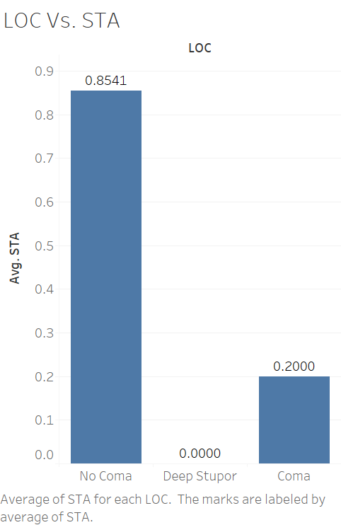

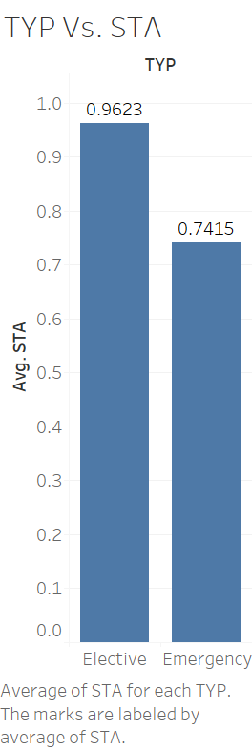

2. Construct a predictive model for the Myopia Study dataset. Myopia within the first five years is the dependent variable in the study.

1. What is the false positive rate for the model? (2 pts.)

* False Positive Rate (FPR): 0 %

1. What is the false negative rate? (2 pts.)

* False Negative Rate (FNR): 100 %

1. Which factors are important in the prediction of myopia? (3 pts.)

* DADMY: Was the subject’s father myopic? with weight of 0.33 (Yes, He has myopic)
* ACD with weight of 0.25
* MOMMY with the weight of 0.22

d. Visualize the effects of the top 2 variables (3 pts.)



